INNOVATE TO INSPIRE

Making to think yourself out of the box while ensuring your everyday operations running smoothly, is a challenge. There are no templates or specified path to carve your thoughts to innovate, each innovation comes along it’s own path, inspiring it’s own group of audience. Imagination is something which cannot be replicated or anticipated. The once imitated not inspired can be mere an innovation but can never be an innovation to inspire.

“ There are no dreams too large, no innovation unimaginable and no frontiers beyond our reach.” ~**John S Herrington**

Inspiration can be found from any corner of the world, but if you cannot find your corner in the spear don’t be afraid. The thing about starting again after a failure is in the new start you carry the experience the knowledge you have gained from your failure to move ahead again in an enhanced way thins time. So, after every failure you don’t fall weak, you become wiser.

“Success contains of going from failure to failure without loss of enthusiasm. ” ~**Winston Churchill**



Although Gates failed at his first business, it didn’t discourage him from trying again. He didn’t want to give up because the sheer notion of business intrigued him. He was cleverly able to put together a company that revolutionized the personal computing marketplace. And we all know just how successful that was for him.

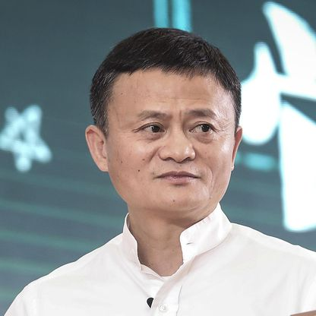

Jack Ma is a true rags-to-riches story. He grew up poor in communist China, failed his college entrance exam twice, and was rejected from dozens of jobs, including one at KFC, before finding success with his third internet company, Alibaba.

Not all the success comes in any particular way, nor the time to reach the success is defined. But one thing that is assured by continuous tries is success. Every new and unique idea in a room will have criticism been thrown at it, but it is the room of your mind where it should only face positive push and the will to execute without the fear of any kind of result. To the people who criticize those ideas who have just two option, **either prove them wrong or prove yourself right.**

“Failure is unimportant. It takes courage to make a fool of yourself.” **~Charlie Chaplin**

In an article by Harvard Business Review it says, Imagine a car motor that lacks a transmission, timing belt, water pump, or starter. The engine may be otherwise well built, but without just one of these components, it will be essentially worthless. So it is with innovation. However much brainstorming your employees do, it will come to naught if they don’t have access to the seed money they need to prototype and test their ideas. Likewise, no matter how slick your company’s online idea market, it won’t yield many high-value ideas if your associates haven’t been taught to think like innovators.

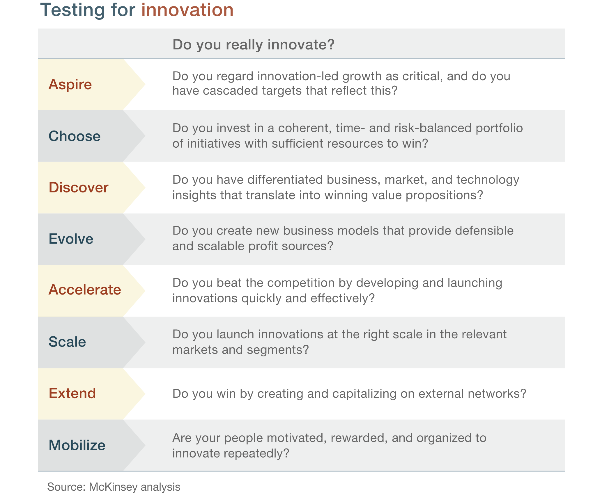

Getting to an idea is one thing and making it innovative is another. On the journey from the brainstorming of idea to making is innovative is what makes it inspirational.

“ Make your life a masterpiece, imagine no limitations on what you can be, have or do.” ~**Brian Tracy**